**A MOBILE APP FOR STUDENT CLASS RECORDS**

A MINI THESIS SUBMITTED IN PARTIAL FULFILMENT

OF THE REQUIREMENTS FOR THE DEGREE OF BACHELOR OF

SCIENCE IN COMPUTER SCIENCE

OF

THE UNIVERSITY OF NAMIBIA

BY

PETRUS HISHEKWA

201304628

**APRIL 2019**

MAIN SUPERVISOR: **PROF. RAFAEL RODRIGUEZ PUENTE**

# **ABSTRACT**

Computers can as well learn just like humans do though it is not as accurate as humans can do. However, they faster to learn and find patterns from a lot of data within a shorter time than humans. In today’s world the terms Artificial Intelligence and Machine Learning are playing a major role in the advancement of technology for today and the future. Programs ranging from mobile, web and desktop applications are being developed to ease our everyday activities. In the educational industry most of the activities have to be computerised to facilitated the processes and improve efficiency and efficacy.

This paper is looking at the design of a mobile application that strive to facilitate some of the main activities in educational industry such as taking attendance and recording marks that a lecturer or a teacher has to do. The designed app uses Artificial Neural Networks to automatically identify students from the student card, and it will also be able to record marks by pointing the camera cell phone to the student scripts after the lecturer mark them. The training of the model is done with TensorFlow, an open source machine learning framework made by Google. This app is facilitating the process of having an updated register of student attendance and continuous assessments, and it is especially useful for classes with a large number of students.

the database and to the class attendance. The lecturer will be able to view, share or print out the class attendance. The app can have attendance lists for several modules and it will be able to calculate the attendance percentage of a student.

**Table of Contents**

**ABSTRACT** i

**TABLE OF FIGURES** iv

**ACKNOWLEDGEMENT** vi

**ARCRONYMS** vii

**1.** **INTRODUCTION** 1

**1.1.** **Background of the study** 1

**1.2.** **Problem Statement** 3

**1.3.** **Objectives** 3

**1.5.** **Limitations** 4

**2.** **RELATED WORK** 5

**3.** **DEVELOPMENT METHODOLOGY** 7

**3.1.** **Research Design** 7

**3.2.** **Functional Requirements** 9

**3.3.** **Artifacts** 11

**3.3.1.** **User Stories** 12

**3.4.** **Procedure** 13

**3.5.** **System Architecture** 22

**4.** **RESEARCH ETHICS** 24

**5.** **RESULTS** 25

**6.** **DISCUSSIONS** 26

**7.** **CONCLUSION** 27

**8.** **RECOMMENDATIONS** 28

**9.** **REFERENCES** 29

**APPENDICES** 31

**DECLARATIONS** 35

# **TABLE OF FIGURES**

Figure 1 Agile Software Development methodology diagram 7

Figure 2 Minimum SDK selection 8

Figure 3 Exam paper sample prepared for training 13

Figure 4 Test paper prepared for training 14

Figure 5 Student card prepared for training 15

Figure 6 Xml files with bounding boxes generated by labellingImg.py 16

Figure 7 Converting xml file to csv file 16

Figure 8 Splitting the dataset into training and testing dataset 17

Figure 9 Training the model 18

Figure 10 TensorBoard showing lose 19

Figure 11 Checkpoints after training 20

Figure 12 Checkpoints combined in one protobuf file 21

Figure 13 Recognising student number and name on the student card 21

Figure 14 Database modelling 23

Figure 15 Converting csv to ftrecord 31

Figure 16 Model configuration file 32

Figure 17 Object labels file 32

Figure 18 App snip code and files 33

Figure 19 Apps home screen 34

# **ACKNOWLEDGEMENT**

I would like to express my sincere appreciation and gratitude to the following people: First and foremost, The Almighty God for the gift of life, strength, protection and health during the duration of my study. Secondly, I thank my supervisor, Pro. R. R. Puente for the support, guidance, and advice during my mini thesis work. I also express appreciation to my fellow students and various lecturers in the University of Namibia’s Faculty of Science, School of Computing for the guidance and motivation throughout the course of my study. Finally, a big thanks to my family and close friend for their support, understanding, love and patience.

I thank you all.

# **ARCRONYMS**

**ANNs**: Artificial Neural Networks, these are biologically inspired computer programs designed to simulate the way in which the human brain processes information [1].

**RFID**: Radio Frequency Identify is a technology that is used to identify objects from a distance by identifying the tag’s information attached on the object, it does not require a line of sight for identification [2].

**GSM**: Global System for Mobile is a network system that provide terminal and personal mobility via the subscriber identity module [3].

**CCTV**: Closed-Circuit Television is a video camera used to closely monitor and record images on any individuals or groups [4].

**pb**: stands for protobuf

**ckpt**: stands for checkpoint

# **INTRODUCTION**

## **Background of the study**

Attendance is quite familiar for us, either students or teachers or be anyone from working arena. Taking or giving attendance has become a woo. We rely on conventional methods of pen and paper for attendance. Though, some techniques evolved in recent span of time but doesn’t prove worthy. These are likes of biometric system, RFID system, CCTV camera and more[5]. In most educational institutions, participation of students in learning process is regarded as a vital exercise for allowing knowledge transfer. This signifies the importance of having students to attend the scheduled lectures and classes. Conventional methods for recording students’ attendance are still adopted by most colleges. One common method is by having students to manually sign the attendance sheet, which is typically passed around the classroom while a lecturer is giving the lecture. This approach could undoubtedly allow the students to cheat about their attendance, where a student may sign for an absent student. Besides, such attendance sheet could easily be misplaced or lost[6]. On the other hand continues assessment recording is another problem considering there are hundreds of students in a class or two and it’s all by one lecturer.

The university accommodates a large number of people at one time and even most frequently in one room as classrooms. In this particular instance the people being accommodated here are students and they can be hundreds of them in one classroom. These hundreds of students are just being served by one lecturer and the hundreds of continues assessments is supposed to be taken for every student. This becomes an issue as an important amount of time is spent on recording the marks in a spread sheet manually.

This research project is aiming to solve the problem of recording continues assessments in a large group of students by making the process easier. A mobile application is developed to scan for a student number and name on the exam and test paper. To achieve this goal, Artificial Neural Networks was used to simplify the process of recording continues assessments.

## **Problem Statement**

Modules with a large number of students have difficulties in updating continues assessments.

## **Objectives**

The objective of this research project is to design and implement a mobile based student class record to:

• Facilitate the process of recording continues assessments.

• Additionally, allow lecturers to have two softcopies of their students’ attendance register.

• Train a machine learning model to recognise student number and name.

• Generate reports detailing a student's attendance details over a certain period of time.

* 1. **Motivations**

Developing a system as such will facilitated the process of students’ class records. Too much time is spent on recording the marks on the excel sheet. It will serve as a basis to facilitate registering the marks of each student. Machine learning can do almost everything a human can do; in a much faster way thus the inclusion of ANNs.

## **Limitations**

There are no any barriers preventing the accomplishment of the research project.

# **RELATED WORK**

This section, is going to review few related systems and their different methods in recording students’ attendance.

An RFID based attendance system [6], [7] is developed to record students’ attendance during class hour as the students enter the class. This system requires each classroom to be installed with an RFID reader that is connected to a computer. The RFID reader was used to capture the student information through the student card. To view the overall student attendance, the lecturer may later connect their phone via Bluetooth to the computer. However, there were problems of environmental factors like light, change in identity can lead to choke at a point. We can't use such system for multi-purpose usages[5]. Another project was using Blue-tooth or Wi-Fi [5]. Attendance is being taken using instructor's mobile phone. A Software is installed in his phone which enables others to interact and query. Bluetooth or Wi-Fi connection works for marking one's attendance. This System had a problem of impersonation. First, availability of mobile was necessary and secondly, impersonation was expected[5].

On another project the Web-based attendance system was developed [8], while the lecture is going on the mobile with the installed system is passed on and students have an option to sign for their attendance with either the selfie or with the signature and the image of photo and hand-written signature are stored into the ‘RollSheet’ database after the lecture by clicking ‘send to the server’ button in the administration mode of the device. This attendance system was addressed with Biometric technology [9], [10]. This system involves the finger enrolment and finger matching. The limitations of this system were misusing the technology by placing a fake finger print and modules are sensitive and they need to be handled carefully.

An alternative approach was introduced in [11], [12], where the system promotes fingerprint based students’ attendance recording system with GSM utilization. By using this system, each student attendance is validated once the student’s fingerprint is verified by the reader. In addition to the strict attendance verification and recording, the system will send weekly attendance report to the students’ guardians via GSM. In another project IoT based system was developed [13], this system uses fingerprint recognition to identify the student, proxy attendance can’t be marked, attendance is sent to server in real time, all the calculations are done by the server and students can check their attendance in real time.

On solving the attendance system problem, the solution was presented with the approach of facial recognition based system with raspberry pi 2 and the eigen algorithm [14]. This face recognition-based attendance management system with raspberry pi 2 using Eigen faces algorithm is high secured, high efficient and accurate. The module espies the images of student’s face captured by the camera, which have been catalogued manually with their names and ID codes in the system database. In another project Face recognition with RFID [15], in this RFID system, the student shows RFID tag which initiates the camera and a face is captured and recognized so that attendance is marked. During the class hours Ultrasonic sensor is activated. If a student leaves in between the class hours or comes late to the class, Ultrasonic sensor is triggers the camera is initiated, which captures the Image and it will be sent to the server.

The proposed system in this project will try to address the limitations found in the above related works with the main purpose of fulfilling the objectives of the research. The proposed system will use Artificial Neural Networks to reduce the limitations in the earlier developed systems.

# **DEVELOPMENT METHODOLOGY**

Methodology is a system of methods used in a particular area of study or activity. In accomplishing this project determined system was be used in order to make sure that all activities/ tasks and studies need to done are done accordingly. On the research or the study, the project was built on the previous work that was already done in the area of study. The project analysed the methods applied to the field of study and the principles associated with a brunch of knowledge.

## **Research Design**

On the development of the system Agile paradigm was the best that suit this project. The Agile Software Development model [Figure 1] was used with Personal Extreme Programming (PXP). PXP joins the users and developers to define requirements[16]. The existing tools and algorithms will be used to develop a solution to the problem under study.

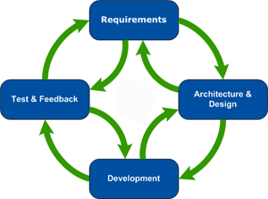

Figure 1 Agile Software Development methodology diagram

The implementation of the system was done in Python programming language with TensorFlow. The model development and the training were done on a laptop computer running windows 10 operating system, the production of the system was first done on the laptop with the webcam before it’s deployed on a mobile device. The system is developed to run on an Android device of a minimum of 14 SDK and later [Figure 2] this will allow the app to run on approximately 100% of devices.

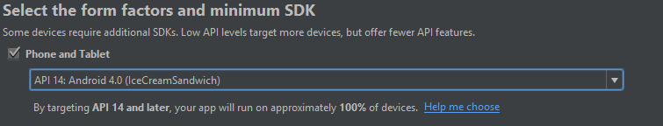

Figure 2 Minimum SDK selection

## **Functional Requirements**

1. Scan the student card for the student number, name* and photo* (The last two can be done at the end, if we have enough time.)
2. Store the attendance list to a database
3. App should run on an android device
4. Use the camera to scan the student card
5. Share/send the attendance with/by emails
6. Export the attendance to an excel sheet
7. Store the data on the device
8. **Database consists of:**
   1. Student records such as:

* Student Number
* Student Name
* Course Name/ code
* Module Name/ code
* Lecturer Name

1. **Attendance list consists of:**

* Student Number
* Module code
* Date

1. **Creating Attendance**
   1. Enter Lecturer Name
   2. Choose a Module
   3. Create Attendance
2. **Done taking attendance**
   1. Save
   2. Share/Send (Optional)

## **Artifacts**

Artifacts are innovations that define the ideas, practices, technical capabilities, and products through which the analysis, design, implementation, and use of information systems can be effectively and efficiently accomplished [17]. The study will present a mobile based attendance register system, which will make use of ANN technology to solve the problem understudy and this system will be developed using the User Story as an artifacts.

### **User Stories**

A user story describes a functionality that is valuable to a user or a customer. It tells a story about the product.

*View Attendance Register*

As a user I want to save the attendance list

*Add a Student*

As a user I want to add a student

*Share attendance list*

As a user I want to share attendance list via emails

*View Attendance list for a Student*

As a user I want to view attendance list for a specific student

*View Attendance list*

As a user I want to view attendance list for a specific date

*Export Attendance list*

As a user I want to export attendance list to excel sheet.

*Add a mule*

As a user I want to add a module

*Take Attendance list*

As a user I want to take the attendance

*Select a Module*

As a user I want to select a module

1

2

9

8

7

5

4

3

6

# **Procedure**

Android studio and Java was used to develop the front end of the system. SQLite was found to be the suitable database management system thus the database was developed using SQLite. The system uses a model that is trained with TensorFlow. A newly trained model was developed since there was no a similar trained model to reuse. Anaconda Prompt was used due to the fact that is the easiest python environment to configure TensorFlow environment for machine learning.

First to prepare the dataset I used labellingImg.py to draw bounding boxes for defining the area of interest on the student card and answer script which is the student number and name and this created xml file for every picture. The student card pictures were manually designed with PrototypeIt web-based platform. The answer scripts were picture that were taken of previous papers.

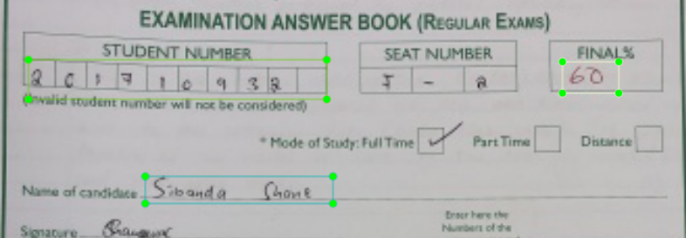

Figure 3 Exam paper sample prepared for training

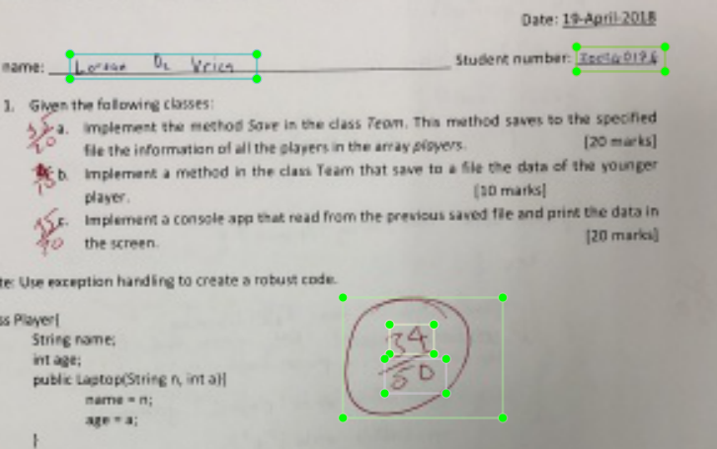

Figure 4 Test paper prepared for training

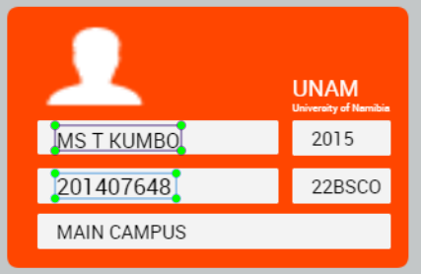

Figure 5 Student card prepared for training

After labelling 438 pictures, the Anaconda and TensorFlow with all the needed tools were installed to my machine. These 438 pictures were divided by 80:20, 80% being for training and 20% for testing. For training, the dataset has to be in the tfrecord format which is the format that TensorFlow can read. Therefore, the xml files were converted into tfrecords.

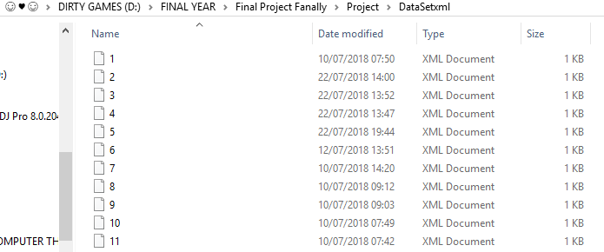

Figure 6 Xml files with bounding boxes generated by labellingImg.py

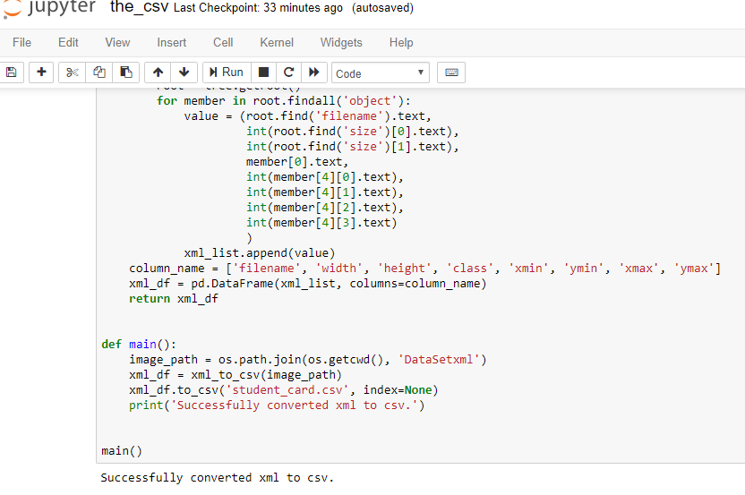

Figure 7 Converting xml file to csv file

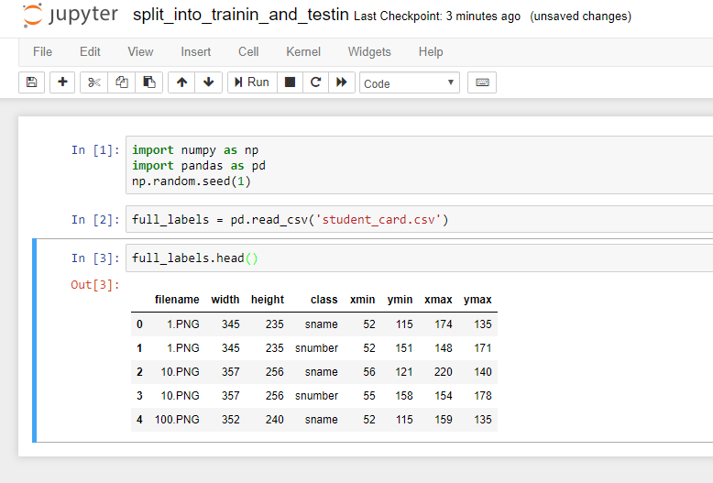

Figure 8 Splitting the dataset into training and testing dataset

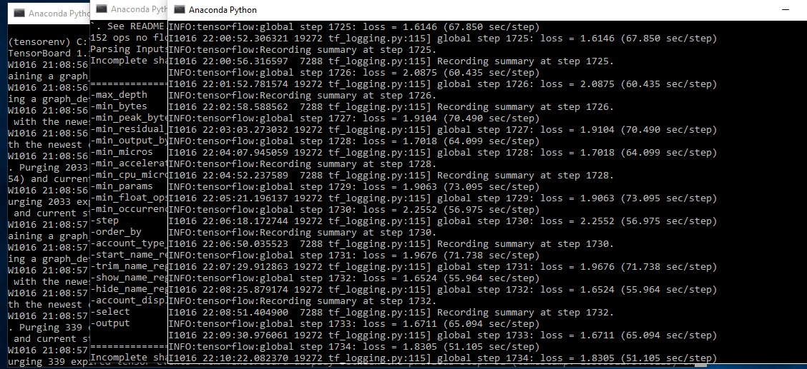

Figure 9 Training the model

The training started and run for four days due to the slow performance of the laptop. The training saves check points automatically so this was very helpful since sometimes I had to restart the process due to the performance of the laptop. With the help of the check point the process could continue from where it was ended. The training started with the loss of 16 and at the end of the training it came down to 1.5. this result were best results and decided to use them as the final model because of the few pictures available. If further training was carried on with then it could have resulted on overfitting whereby the system will not be able to work on the new pictures but only the ones it has trained on. Since this system requires an object to be detected, object detection API for TensorFlow was used.

To train the model **Mobilenet_v2_coco**. Mobilenet was the suitable object detection model since the system is meant for mobile devices, though Mobilenet accuracy is a bit low than other object detection models like **faster_rcnn_inception_v2_coco**, it is found to be fast on mobile devices. Two classes were namely Student Name and Student Number were defined for the training of the model.

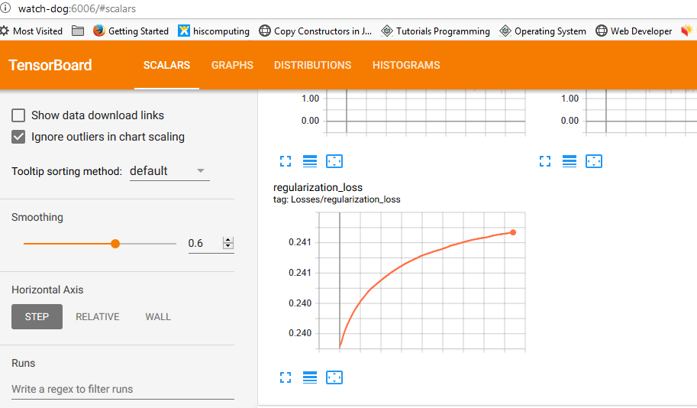

Figure 10 TensorBoard showing lose

To see what happens behind the

To test the newly created and trained model, the last saved check point had to be formatted to the .pb extension from .ckpt, since object detection works best with .pb which is a combination of the ckpt index, data and metadata.

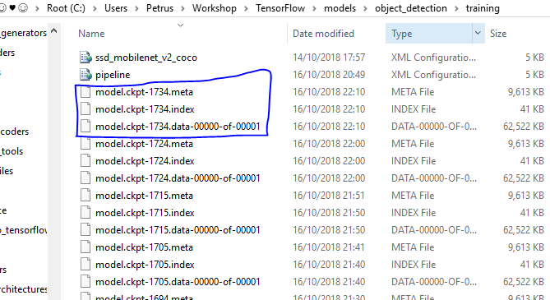

Figure 11 Checkpoints after training

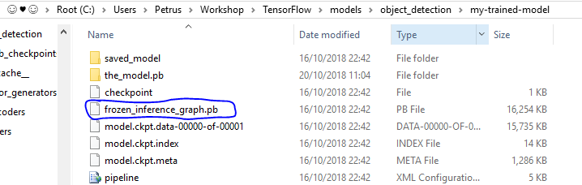

Figure 12 Checkpoints combined in one protobuf file

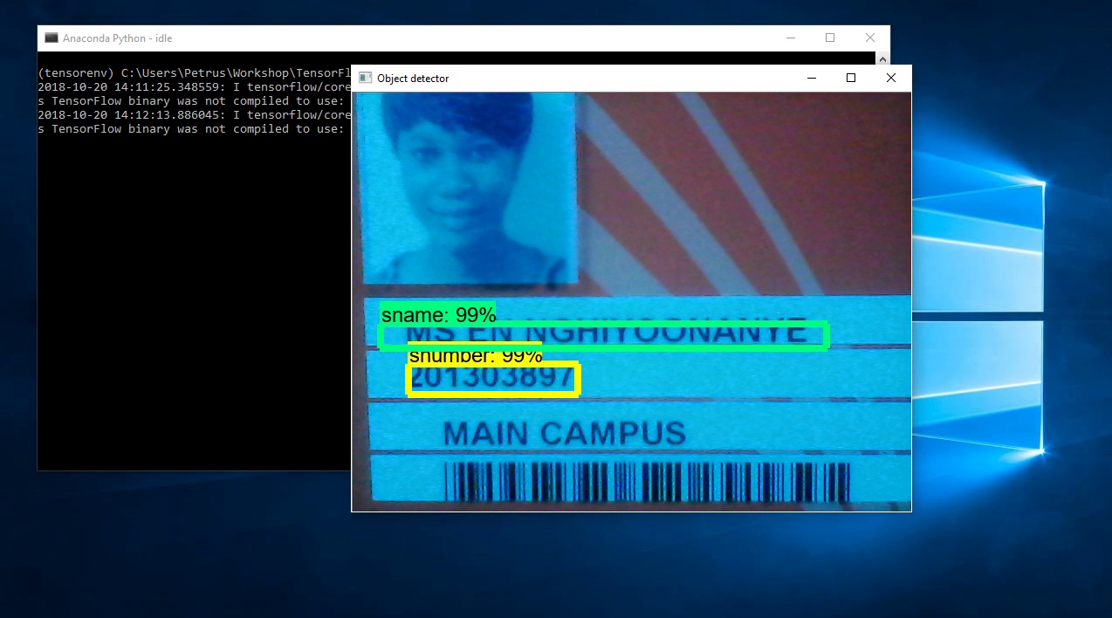

Figure 13 Recognising student number and name on the student card

# **System Architecture**

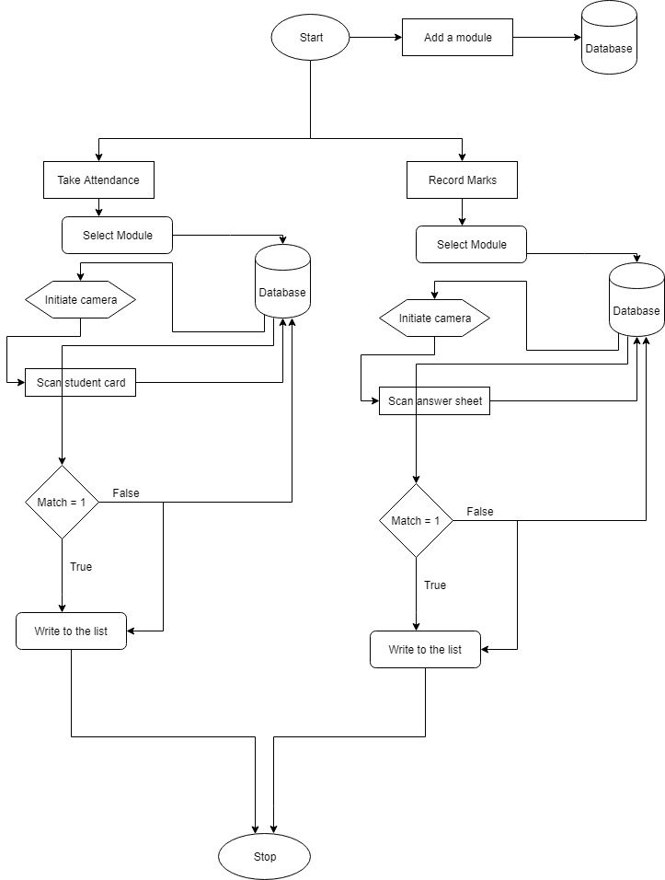

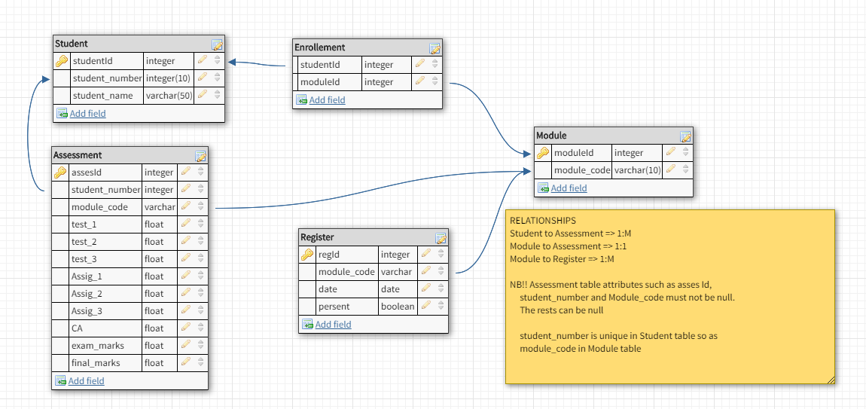

Figure 14 Database modelling

## **RESEARCH ETHICS**

The project had not involved any survey or questionnaire there for there was no consent document needed to be signed. The dataset was designed from scratch where by a sample of student card was designed using *prototypeIt* website. However, the test and exam paper sample were provided by the lecturer which on consists of the student under their administration. The model development was made with readily available tools, like TensorFlow, android and the programming language.

## **RESULTS**

The android application runs on the android device with the minimum of 14 SDK. However, the test could only be run on the devices that run android 5.0.1 Lollipop, android 6.0.1 Mushroom and android 7.0.1 Naught. The application run smooth on these systems. For the lower android OSes like KitKat the application was only tested on the emulator.

ANN model trained with impressive results after 3 days of training though it left the laptop that was doing the training in a very bad condition. The model could read the location of the bounding boxes. It could find the student number and student name bounding box. However, due to over training the model could find false bounding boxes where it will find a student number or name on the student card on the area where there was none of the two. Although it does pick up false bounding boxes it gives the confidence on how sure is it about the identified object.

Using the laptop webcam all works fine and fast on the model. The model couldn’t identify digit by digit and couldn’t identify alphabetical letters. Due to the model that was used to re-train the model, the trained model could quickly identify classes on the image thought it is sometimes picking up false classes. This is because on the available model for mobile devices there are only two ways of doing it which end up compromising one of the two factors, speed and accuracy. The mobile computation process is a low comparing to the laptop or desktop computer therefore speed was opted for over accuracy and this is a problem because the model is fast to grab the information on the image but it does grab other information which could be the noise on the data.

## **DISCUSSIONS**

The ANN model is trained as stated by the objectives and it could identify the student number and student name. The mobile application is developed as the objectives have stated. However, it has failed to implement of reach the objective of being able to give detailing information about the student as per user’s request. The project has the objective of ensuring that the users have a backup since one information is supposed to be in the device while one is exported to the excel sheet on the computer. However, this couldn’t be achieved due to the fact that the ANN model is unable to recognise a sequence of numbers and alphabets.

The project however adds to the list of previous projects that have addressed the issue of student class record as they are stated in related work though it has not fully solved the problem. In its current stage it is acting as a starting point and indication that student class record can be addressed with artificial intelligence and machine learning. When this project is fully done it could be applied in different areas apart from student class record.

Developing of such a project requires more input and time. It needs a fast and high performance for training of the ANN model. The ANN model needed to be two, one for number recognition and the other for alphabets recognition. These two supposed to be mixed to form one ANN model.

# **CONCLUSION**

Artificial intelligence has a most of the solutions to our daily problems and it is quite like a human’s mind on doing things. The project could identify the student number and name on the student card. The mobile application developed. Due to the shortcomings of the project it did not solve the entire problem and achieve the objectives as proposed. The shortcomings of the project are such as inability to recognise sequences of digits, inability to recognising English alphabetical letters and special characters.

Training an ANN model was a lesson learned, this project taught the use of TensorFlow, object detection models, how to train and retrain a machine learning model, introduces and exposed me to different model configuration file. I learned how to configure a model for training, how to froze a model so that it can be ready for deployment into production. I learnt to configure the Anaconda environment for TensorFlow, learnt how to prepare a dataset with labellingImg. Connecting a model to the android application was a very important lesson learnt as well.

This project could be applicable almost every where be it in educational industry as it is the initial focus. It can as well be applied at other organisation where record keeping of information based a person’s identification is required. The project could also be used for signing or clocking in and out at work places or hostels. When it is able to recognise sequential digits, it could be used to identity fake number plates and taxi signs by comparing it to those real one with the authority.

# **RECOMMENDATIONS**

There future project on this topic should continue on the project to enable it to recognise sequential digits and alphabetical letters as well as special characters since some names like Nama Damara name contains special characters. The next work should include both many institution identification cards. The compromise of one factor when choosing which model to use should be addressed that is to say a hybrid model that include speed and accuracy both equally for mobile device ANN model should be developed.

Another more project should be done on this topic using computer vision as only few project and research paper are done addressing the issue with use of computer vision. The future project and research should look at addressing this issue with machine learning with the raspberry pie devices and this can be cheaper to avail for every student or just one that can be mount on the wall at the entrance.

# **REFERENCES**

[1] S. Agatonovic-Kustrin and R. Beresford, “Basic concepts of artificial neural network (ANN) modeling and its application in pharmaceutical research,” *J. Pharm. Biomed. Anal.*, vol. 22, no. 5, pp. 717–727, Jun. 2000.

[2] R. Want, “An introduction to RFID technology,” *IEEE Pervasive Comput.*, vol. 5, no. 1, pp. 25–33, Jan. 2006.

[3] M. Rahnema, “Overview of the GSM system and protocol architecture,” *IEEE Commun. Mag.*, vol. 31, no. 4, pp. 92–100, Apr. 1993.

[4] V. S. Asirvadam *et al.*, “Risk map for video surveillance CCTV,” in *2014 5th International Conference on Intelligent and Advanced Systems (ICIAS)*, 2014, pp. 1–6.

[5] H. Kasyap, “Android Based Smart Attendance System.”

[6] S. A. M. Noor, N. Zaini, M. F. A. Latip, and N. Hamzah, “Android-based attendance management system,” in *2015 IEEE Conference on Systems, Process and Control (ICSPC)*, 2015, pp. 118–122.

[7] D. K. Sarker, N. I. Hossain, and I. A. Jamil, “Design and implementation of smart attendance management system using multiple step authentication,” in *2016 International Workshop on Computational Intelligence (IWCI)*, 2016, pp. 91–95.

[8] J. Iio, “Attendance Management System Using a Mobile Device and a Web Application,” in *2016 19th International Conference on Network-Based Information Systems (NBiS)*, 2016, pp. 510–515.

[9] V. O. Adeniji, M. S. Scott, and N. Phumzile, “Development of an Online Biometric-enabled Class Attendance Register System,” in *2016 IST-Africa Week Conference*, 2016, pp. 1–8.

[10] N. tafadzwa Nzongo, “Development of Academic Attendence Monitoring System Using Fingerprint Identification.”

[11] R. Singh, “RFID, ZigBee and GSM Based Attendence Monitoring System.”

[12] K.Jaikumar, “FINGERPRINT BASED STUDENT ATTENDANCE SYSTEM WITH SMS ALERT TO PARENTS,” *Int. J. Res. Eng. Technol.*, vol. 04, no. 02, pp. 293–297.

[13] I. Journal, “IoT based attendance system.”

[14] S. Gaddam and A. Sarfraz, “FACE RECOGNITION BASED ATTENDANCE MANAGEMENT SYSTEM WITH RASPBERRY PI 2 USING EIGEN FACES ALGORITHM.”

[15] I. J. of S. R. in S. and T. Ijsrst, “Effective Automatic Attendance Marking System Using Face Recognition with RFID.”

[16] J. Henry, “Adopting an Agile Process,” in *Software Project Management*, United State of America: Pearson Education, 2004, pp. 39–40.

[17] F. Neto and I. Francisco, “Developing an automatic attendance register system.”

# **APPENDICES**

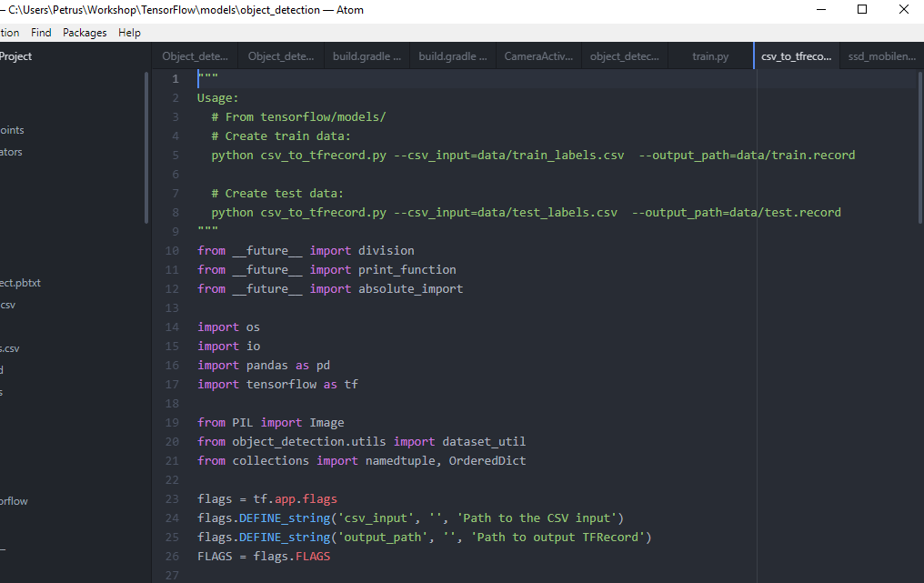

Figure 15 Converting csv to ftrecord

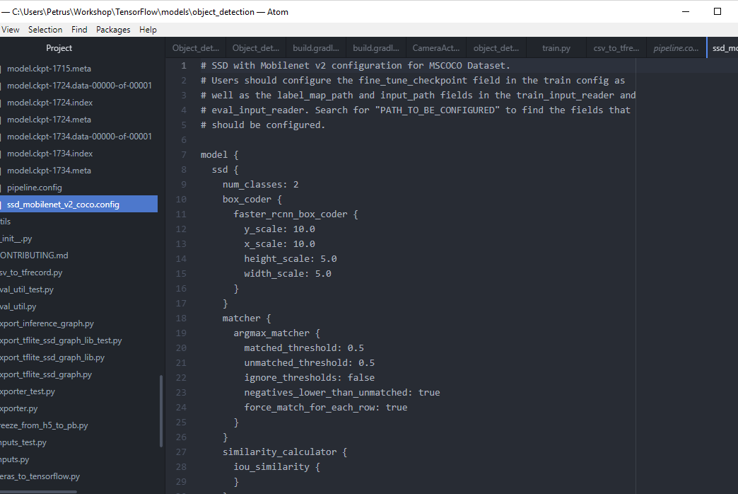

Figure 16 Model configuration file

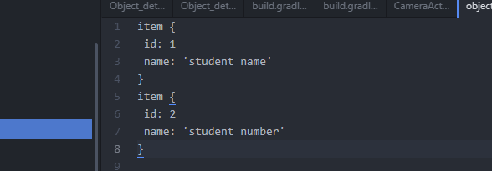

Figure 17 Object labels file

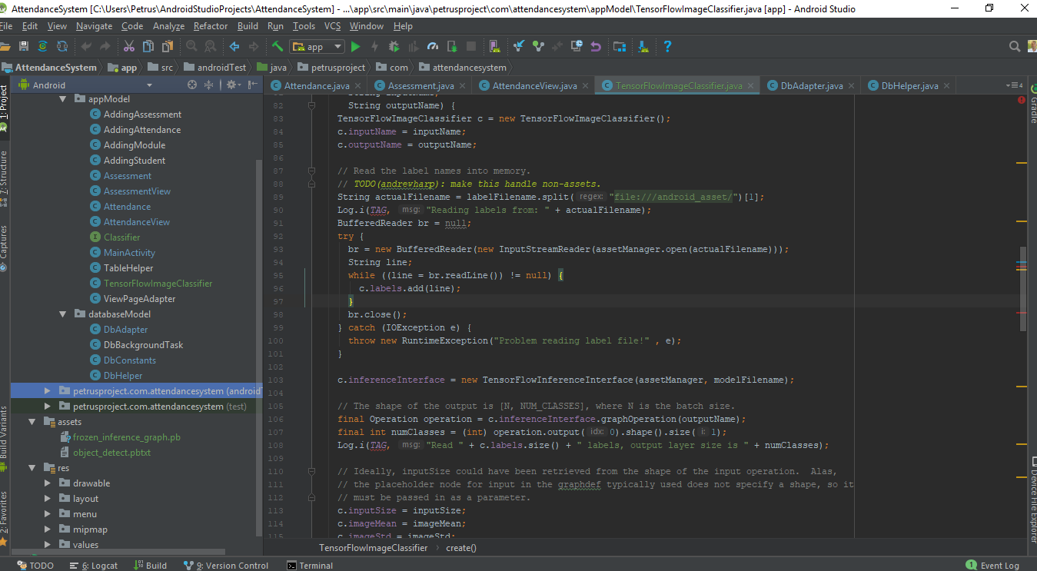

Figure 18 App snip code and files

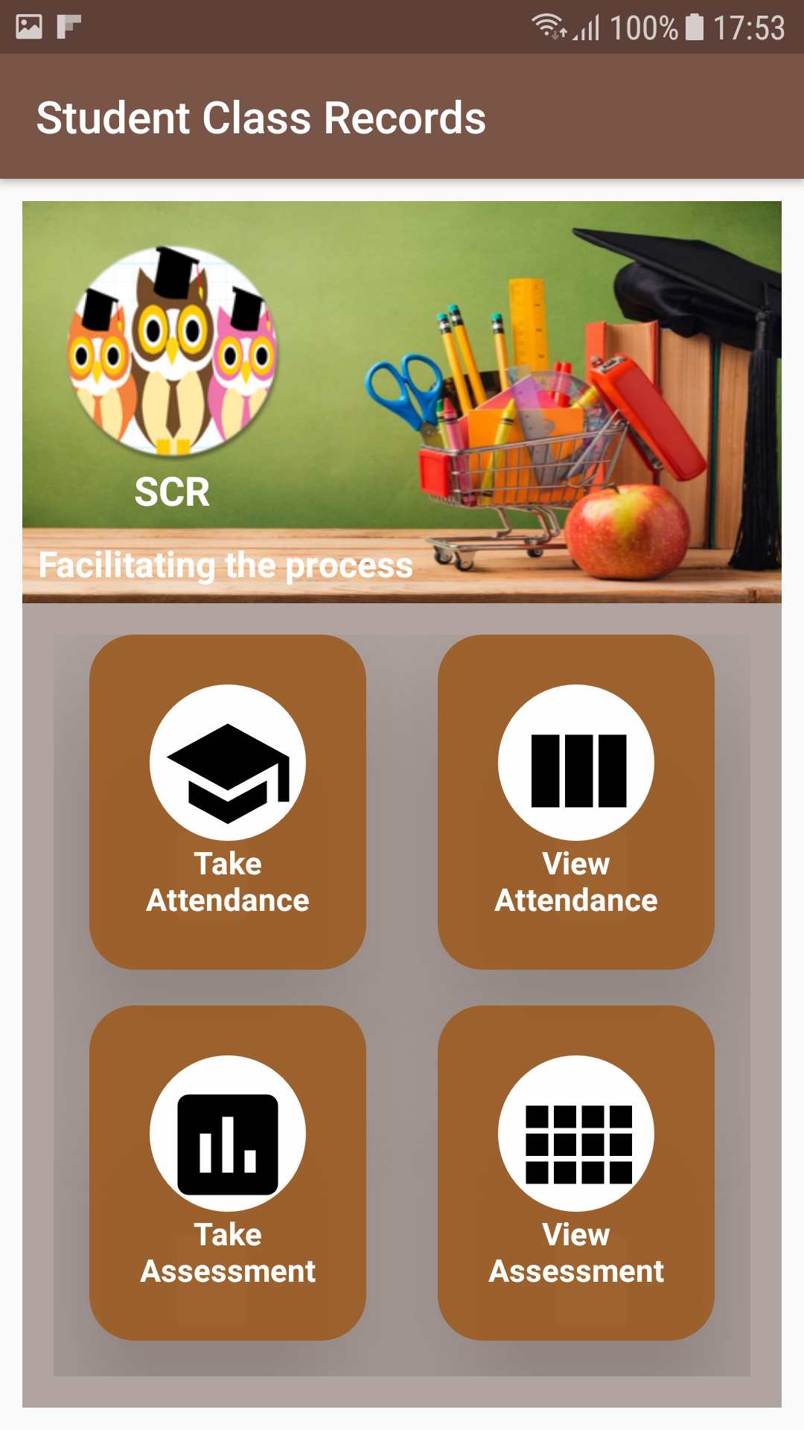

Figure 19 Apps home screen

# **DECLARATIONS**

I, PETRUS HISHEKWA, hereby declare that this study is my own work and is a true reflection of my research, and that this work, or any part thereof has not been submitted for a degree at any other institution.

No part of this thesis may be reproduced, stored in any retrieval system, or transmitted in any form, or by means (e.g. electronic, mechanical, photocopying, recording or otherwise) without the prior permission of the author, or The University of Namibia in that behalf.

I, PETRUS HISHEKWA, grant The University of Namibia the right to reproduce this thesis in whole or in part, in any manner or format, which The University of Namibia may deem fit.

……………….……………… ……………………………… ….…………   
**Name of Student Signature Date**